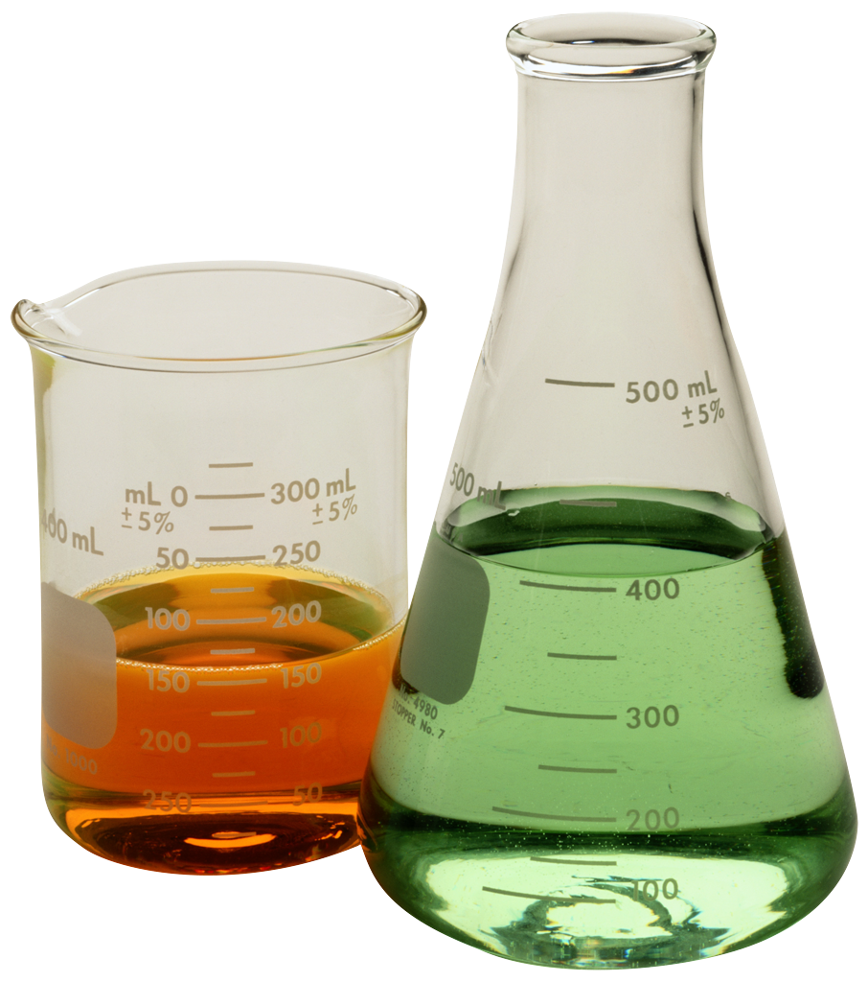
Physical and chemical changes

What is a physical change? ________________________________________________________

What is a chemical change? _______________________________________________________

Identify each of the following as a physical or a chemical change. Then, explain why each is a chemical or physical change.

- You leave your bicycle out in the rain and it rusts___________________________
_______________________________________________________________________________________________________________________________________________________

- A sugar cube dissolved in water____________________________________________
_______________________________________________________________________________________________________________________________________________________

- Pure potassium is normally stored in oil. When the oil is removed, a flame is produced because the potassium can now react with oxygen in the air_________________________________________________________________________
___________________________________________________________________________
___________________________________________________________________________

- Sand is mixed with water___________________________________________________
_______________________________________________________________________________________________________________________________________________________

- Scientists break up water (called hydrolysis) by separating it into 02 and H2_________________________________________________________________________
________________________________________________________________________________________________________________________________________________________

- You are cleaning your bathroom and you accidentally mix bleach and ammonia, which produces a toxic gas, which makes you pass out________________________________________________________________________
________________________________________________________________________________________________________________________________________________________

- Burning coal for a barbecue ________________________________________________
________________________________________________________________________________________________________________________________________________________

- Chewing up a bite of hamburger____________________________________________
_______________________________________________________________________________________________________________________________________________________

- You take a shower and your wet hair begins to dry___________________________
________________________________________________________________________________________________________________________________________________________

- Silver nitrate and sodium chloride mix to form a grey-violet precipitate ____________________________________________________________________________
_______________________________________________________________________________________________________________________________________________________

- Trimming a plant because it has grown too high _____________________________
________________________________________________________________________________________________________________________________________________________

- Mashing up potatoes to make mashed potatoes _____________________________
________________________________________________________________________________________________________________________________________________________

- Hydrogen peroxide is poured on some liver, the liver begins to break down ____________________________________________________________________________
________________________________________________________________________________________________________________________________________________________

Write your own example below and identify it as a chemical or physical change and explain why.

______________________________________________________________________________________________________________________________________________________________________________________________________________________________________________________

Identify each statement as true of false

- A change in size or shape is a physical change

- A chemical change means a new substance with new properties was formed

- An example of a chemical change is when water freezes

- When platinum is heated, then cooled to its original state, we say this is a physical change.

- When milk turns sour, this is a physical change because a change in odour does not indicate a chemical change.

- When magnesium is burned, ash forms. We say this is a physical change because the magnesium looks different.

- When citric acid and baking soda mix, carbon dioxide is produced and the temperature decreases. This must be a chemical change.

Signs that a physical or chemical change has occurred. Fill in the spaces
(size, colour, light, odour, sound, state, bubbles, heat, shape)

Physical change | Chemical change
A change in S_____________________ | A change in C_____________________
A change in S_____________________ | B_______________________ given off
A change in S_____________________ | O_______________________ given off
 | H_______________________ given off
 | L_______________________ given off
 | S_______________________ given off
 | A P_____________________ is formed


TEACHER DEMONSTRATIONS

1. Burning a match

Record as many observations as you can___________________________________________
__________________________________________________________________________________

Was this a chemical or physical change? Why? ____________________________________________________________________________________________________________________________________________________________________

2. Ripping a piece of paper into small pieces

Record as many observations as you can___________________________________________
__________________________________________________________________________________

Was this a chemical or physical change? Why? ____________________________________________________________________________________________________________________________________________________________________
3. Ice left in a container at room temperature

Record as many observations as you can___________________________________________
__________________________________________________________________________________

Was this a chemical or physical change? Why? ___________________________________________________________________________________________________________________________________________________________________

4. Coke bottle rocket

Record as many observations as you can___________________________________________
__________________________________________________________________________________

Was this a chemical or physical change? Why? ____________________________________________________________________________________________________________________________________________________________________

5. Hydrogen balloon

Record as many observations as you can___________________________________________
__________________________________________________________________________________

Was this a chemical or physical change? Why? ____________________________________________________________________________________________________________________________________________________________________

6. Mixing solutions – Potassium iodine with lead nitrate

Record as many observations as you can___________________________________________
__________________________________________________________________________________

Was this a chemical or physical change? Why? ____________________________________________________________________________________________________________________________________________________________________

Which of the changes demonstrated by the teacher were

Physical? _______________________ Chemical? ______________________
_______________________ ______________________
_______________________ ______________________

